**GEAR BENDING STATEMENT OF WORK**

**Work Summary: 12 weeks**

* Phase 1: Virtual Life Method (VLM) model development
  + Develop model and predict the lives of one (1) gear each of three (3) different Steel materials.
  + Prediction is driven by gear geometry, gear materials and metallurgical characteristics, each subject to specific test conditions. (See Schematics and Photograph of the Test Setup)
  + Prediction is also governed by the stresses obtained from the FEA output results. (Stress Plot Figures)
* Phase 2: Correlation study
  + Correlate data from virtual tests with known test data for each supplier’s bearing design. Eaton to provide physical test results after Phase1 is complete.
  + If modifications to the system model are required to achieve correlation, define what alterations
* Metallurgical characteristics, rollers and rings, to include:
  + Inclusions: size, type, density
  + Carbide banding, stringers, etc.
  + Grain size and transition zone
  + Case to core transition zone
  + Residual stress distribution
  + % retained austenite
  + Austenitic pools
  + Surface and core hardness, hardness gradient
  + Other features as required (if not listed above, please add)
* Report out to include:
  + Predicted life and operating stress levels of gear for each material.
  + Material Model details and metallurgical characteristics assessed

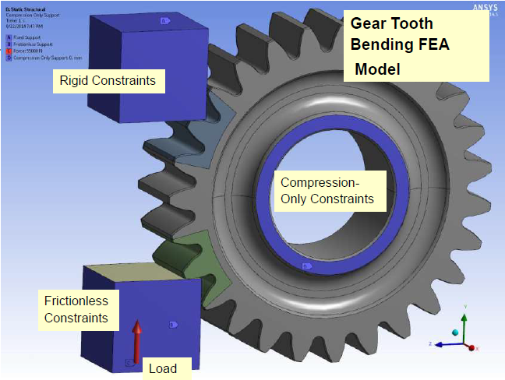

**Supporting Information to be provided by Eaton:**

* Test samples
* Material data, FEA data, Operational input
* Additional information needed to be determined.

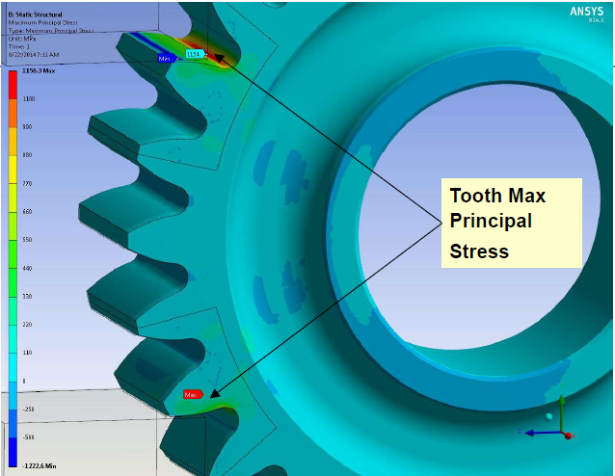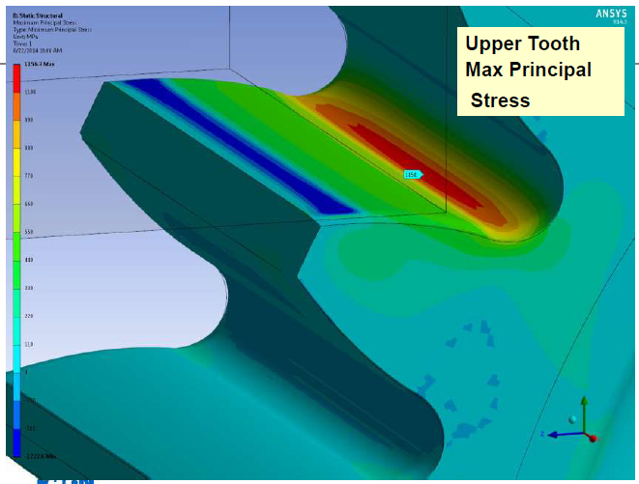

**Proposal to Include:**

* Cost for modeling and appropriate measurements
* Timing to complete your analysis from time parts and information is received by VEXTEC.

